SL4J Logging Exercise

# Exercise 01 – Logging Error Messages and Warning Levels

pom.xml

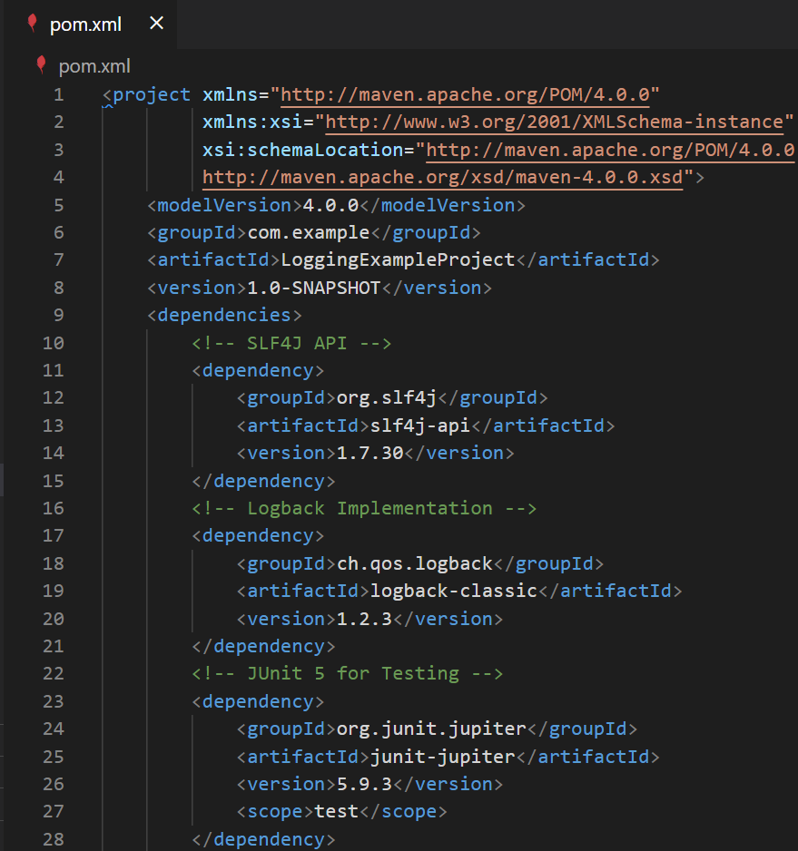

LoggerFactory.java (src\main\java\com\example)

LoggingExample.java (src\main\java\com\example)

logback.xml (src\main)

LoggingExample.java (src\test\java\com\example)

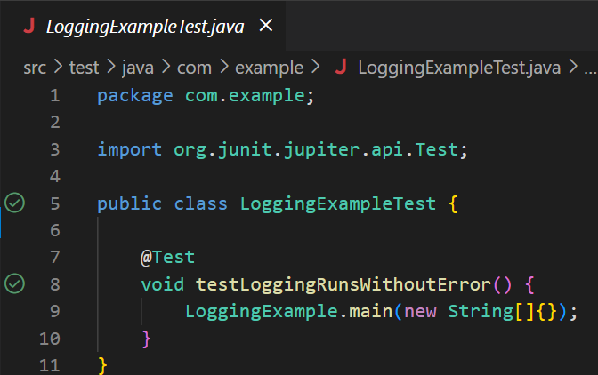

Output: (In new Terminal)

Output: (Run the @Test)

